**Experiment** :6

Aim : Command running thorough the cmd windows.

Procedure:

Step 1: open windows command prompt and Type tracert command and type tracert www.saveetha.com -> “Enter”

Step 2: Type ping command and type IP Address press “Enter

Step 3:type if config command

Step 4:type netstat command.

**Commands:**

**1.tracert**

**2.if config**

**3.netstat**

**4.netstat -a**

Output:

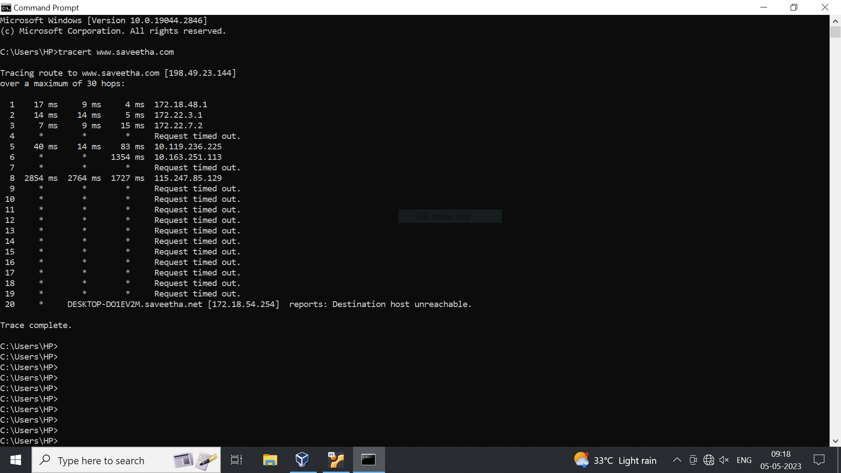

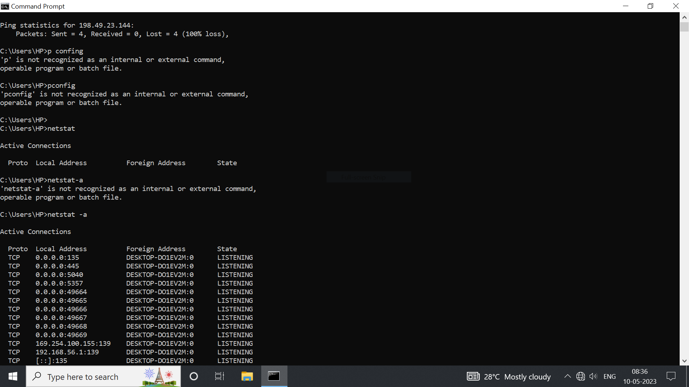

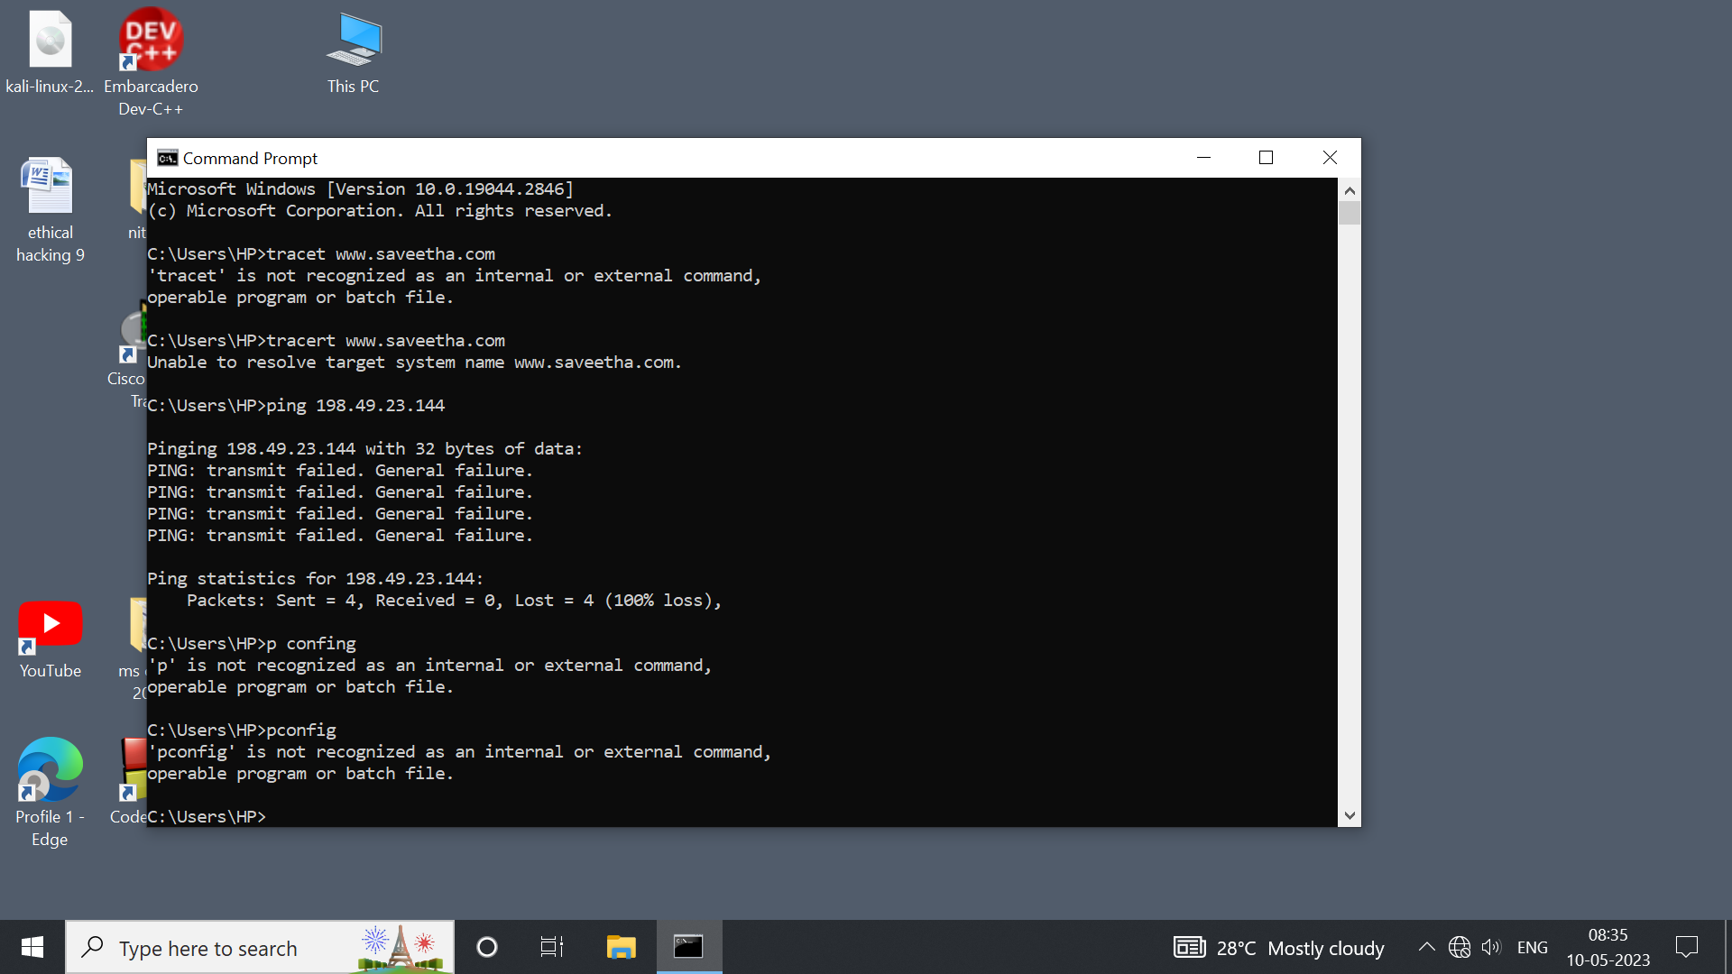

Step 3: Type ifconfig command

step 4: type netstat

Output: